Hayool Lee, violin
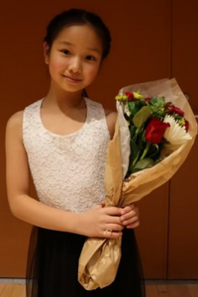
Hayool Lee was born in Busan, South Korea in March 2012. She loved music from an early age and was interested in many musical instruments. She was actively involved and excelled in young girl’s ballet group in Korea until she had to move to the States in 2018 with her family. She is now 10 years old and a 5th grader at Central Trail Elementary in Sylvania.
Hayool started playing the violin when she was in the 2nd grade. This is the third year of playing the violin. In the beginning, learning violin wasn’t easy for Hayool, due to the language barrier. However, her love and appreciation of music made it easier to advance quickly.
She is currently studying violin under Dr. Vasile Beluska direction, and she is his youngest student to date. Aside from violin, she has been learning to play the piano with Mr. Kevin Reilly.
Hayool has been volunteering to play the violin at the Hanmi Covenant Presbyterian Church for the last two years.
In 2021, Hayool joined the Toledo Symphony Youth Orchestra Symphonic strings. That same year, she also won the Toledo Symphony Youth Orchestra solo competition.
Hayool has a real passion for music, and it is a great source of comfort and encouragement to her. She is consistent in listening and practicing violin and piano daily. Outside of music, she enjoys drawing, painting, reading fantasy and mystery books.
Hayool aspires to have more opportunities to perform on stage in the future. She delights in giving audiences pleasure from her musical performances.
This competition has been a great opportunity for her to take a first step towards her musical growth.

Mary Borus, saxophone
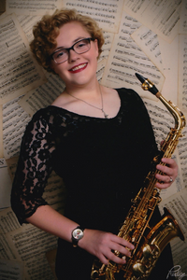
Mary Borus is a resident of Bowling Green, Ohio and a native of Shelby Township, Michigan. Having studied the Alto Saxophone for 9 years, she has earned a great deal of musical experience both in group performance and solo performance. Now studying under Dr. John Sampen at Bowling Green State University, she is working on a Bachelor’s degree in Music Performance and plans to minor in Business Administration. In Mary’s solo career, she won the North Oakland Concert Band Concerto Competition and performed with the North Oakland Concert Band, earned an honorable mention in the Ohio University Concerto Competition, and was a finalist for the Ann Arbor Concert Band Scholarship Competition. As a musician in larger groups and ensembles, Mary has participated as the principal alto saxophonist in the Detroit Symphony Youth Wind Ensemble and been the saxophonist on retainer for the Detroit Metropolitan Youth Symphony. She is also a recipient of the John Phillip Sousa Award, received in May of 2022.
In her studies at Bowling Green State University, Mary is an active member of her saxophone studio and currently performs as a section leader in the Symphonic Band. Outside of her performance studies, she participates in the Bowling Green State University Falcon Marching Band and Athletic Band and works as the band librarian for the College of Musical Arts. She looks forward to performing with the Toledo Symphony!

Miki Kawamura, piano
Miki Kawamura is a 10th grader at Findlay High School, training in classical piano for 11 years with Kathleen Price. Starting piano at age 5, she has won numerous awards across states, including first place in the 2019 Junior Division of the Friends of Fort Wayne Symphony Concerto Competition, 2nd place in the 2021 Marylin Walter Young Musicians Award, 3rd place in the 2022 Charlotte and W. Alfred Gray Competition, and many more. In addition to piano competitions, Miki also participates in the National Guild of Piano Teachers' yearly auditions at the National level and in the Ohio Federation of Music Clubs, in which she has participated 10 years of piano solo, with all superior ratings, and 7 years of piano concerto. Aside from piano, Miki plays first violin in her school orchestra and participated in the Northwest Region Orchestra in 2021 and 2022. She is also very involved in ballet, training at the Findlay Academy of Ballet with instructor Judith Reading. Miki performed in the Toledo Ballet’s 82nd Nutcracker in 2022 as a soloist and a corps de ballet member in numerous roles.
When Miki is not dancing or playing piano, she enjoys sewing clothes, cooking, and listening to music.

